Atlantic Theoretical Chemistry Symposium 2010

August 13-15, 2010

Saint Mary’s University
923 Robie Street
Halifax, Nova Scotia

Conference Program

Sponsors

We are grateful to the following sponsors for financial and/or in kind help.

Scientific Computing and Modeling (SCM)
http://www.scm.com

Wavefunction, Inc.
http://www.wavefun.com

Saint Mary’s University, Department of Chemistry
http://www.smu.ca/academic/science/chemist

Chemical Institute of Canada, Maritime Local Section
http://www.chimiste.ca/sections/maritime/

Canadian Society for Chemistry, Physical/Theoretical/Computational Division
http://www.chimiste.ca/divisions/physical/

ACENet – Institute for Computational Chemistry
http://wiki.ace-net.ca/index.php/Computational_Chemistry

Schedule at a Glance

Friday, Aug 13, 2010
7:00 PM – 8:00 PM Registration Gorsebrook Lounge
8:00 PM – Opening Social Gorsebrook Lounge

Saturday, Aug 14, 2010
9:20 AM-10:20 AM Session 1a AT101
10:20 AM-10:40 AM Coffee Break
10:40 AM-12:00 PM Session 1b AT101
12:00 PM – 1:30 PM Lunch
1:30 PM – 2:50 PM Session 2a AT101
2:50 PM – 3:10 PM Coffee Break
3:10 PM-4:50 PM Session 2b AT101
7:00 PM – 10:00 PM Banquet Gorsebrook Lounge

Sunday, Aug 15, 2010
9:20 AM-10:20 AM Session 3a AT101
10:20 AM-10:40 AM Coffee Break
10:40 AM-12:20 PM Session 3b AT101
Detailed Schedule

Saturday, Aug 14, 2010
Session 1a (chair: Yaoting Zhang)
09:20 AM - 09:40 AM Felix Kannemann (GS, Dal)
09:40 AM - 10:00 AM Shane McCarthy (GS, UNB)
10:00 AM - 10:20 AM Adam Proud (GS, UPEI)
Session 1b (chair: Yaoting Zhang)
10:40 AM - 11:00 AM Jordan Weagle (UG,UNB)
11:00 AM - 11:20 AM Hugo Bohorquez (GS, Dal)
11:20 AM - 11:40 AM Mohammad Halim (GS, MUN)
11:40 AM - 12:00 AM Barbara Goodall (UG, SMU)

Session 2a (chair: Barbara Goodall)
1:30 PM – 1:50 PM Jane Ferguson (UG, SMU)
1:50 PM – 2:10 PM Daniel Whynot (GS, SMU)
2:10 PM – 2:30 PM Jean Gillis (UG, CBU)
2:30 PM – 2:50 PM Margaret Gillis (UG, CBU)
Session 2b (chair: Barbara Goodall)
3:10 PM – 3:30 PM Emilie Hebert (UG, SFX)
3:30 PM – 3:50 PM Laura Albrecht (GS, Dal)
3:50 PM – 4:10 PM Shamus Blair (GS, UNB)
4:10 PM – 4:30 PM Zuzana Istvankova (UG, CBU)
4:30 PM – 4:50 PM Yaoting Zhang (GS, SMU)

Sunday, Aug 15, 2010
Session 3a (chair: Daniel Whynot)
09:20 AM - 09:40 AM Carl Haugen (UG, UNB)
09:40 AM - 10:00 AM Gavin Heverly-Coulson (GS, Dal)
10:00 AM - 10:20 AM Mosammat Khan (GS, MUN)
Session 3b (chair: Daniel Whynot)
10:40 AM - 11:00 AM Sergey Kazachenko (GS, UNB)
11:00 AM - 11:20 AM Simiao Lu (UG, SFXU)
11:20 AM - 11:40 AM Mohammed Uddin (GS, MUN)
11:40 AM - 12:00 AM Victoria Walker (GS,Dal)
12:00 PM – 12:20 PM Jian Wu (PDF, Dal)

Abstracts

UG=undergraduate student
GS=graduate student
PDF=post-doctoral fellow
F=faculty
From the Inside Out: A DFT/QTAIM Evaluation of the Relative Effects of Amino Acids on the Hydrogen Bond Network in Water.

Laura Albrecht (GS, Laura.Albrecht@Dal.ca) and Russell Boyd

Department of Chemistry, Dalhousie University, Halifax Nova Scotia, B3H 4J3

Solvent effects are often necessary to explain protein interactions, for example the formation of secondary structures that will bury hydrophobic side-chains. Typically, research including solvent follows an “outside-in” approach: solvent is included to increase the accuracy of the solute calculation. This, however, is only part of the picture. Recent publications on protein folding show an entropy factor involving the surrounding solvent molecules that drives the protein folding process.[1] There is thus an inside-out perspective where the effect of solute on the solvent is integral in the action of protein folding. Studies focused on the structure of solvent water typically consider statistical averaging of geometrical values, e.g. O-O pair distribution functions [2], and do not evaluate individual properties of the solvent molecules. To investigate the relative stabilizing and destabilizing effects of the 20 amino acids on the surrounding solvent, calculations of each amino acid in explicit solvent will be performed using density functional theory. The hydrogen bond network will be evaluated using the quantum theory of atoms in molecules approach. An understanding of the relative effects of each amino acid on the hydrogen-bonding within the first solvation shell will yield insight as to why some protein sequences promote specific secondary structures based on their solvent interactions.
[1] Kinoshita, M. Int J Mol Sci. 2009 (10), 1064.
[2] Silvestrelli, P. L. J. Phys. Chem. B 2006, 110, 5301-5309

How many intramolecular hydrogen bonds does the oxalic acid dimer have?

Shamus A. Blair (GS,shamus.a.blair@unb.ca) and Ajit J. Thakkar

Department of Chemistry, University of New Brunswick, Fredericton, NB E3B 5A3

Second-order Møller-Plesset (MP2) calculations are used to locate 69 unique minima on the potential energy surface of the oxalic acid dimer. Additional MP2 calculations, with and without scaling of the spin components of the correlation energy, are performed for 24 selected minima using larger basis sets. The global minimum is a dimer in which one of the monomers is not in its lowest-energy rotameric form. This dimer has two intermolecular and three intramolecular hydrogen bonds [1].

[1] S. A. Blair, A. J. Thakkar. Chem. Phys. Lett. (2010) in press.
Ab initio representation of covalent and non covalent interactions in molecules

Hugo J. Bohórquez (GS), Chérif F. Matta and Russell J. Boyd

Department of Chemistry, Dalhousie University, Halifax, Nova Scotia, Canada B3H 4J3 and Department of Chemistry and Physics, Mount Saint Vincent University, Halifax, Nova Scotia, Canada B3M 2J6

The local value of the single-particle momentum provides a direct three-dimensional representation of bonding interactions in molecules. It is given exclusively in terms of the electron density and its gradient, and therefore is an ideal localized electrons detector (LED). LED is able to clearly identify covalent and hydrogen bonding interactions by depicting distinctive regions around the bond critical points, emerging as a complementary tool in conventional atoms in molecules (AIM) studies (HJB & RJB, Theor Chem Acc, DOI: 10.1007/s00214-010-0727-5, 2010).

We show that the graphical representation of bonding interactions given by LED is consistent with the local curvatures of the electron density as given by the eigenvalues of the Hessian matrix, according to a new local symmetry classification of the critical points (HJB, CFM & RJB Int J Quant Chem 110:13, 2418-2425, 2010). LED consistently complements the topological analysis of the electron density given by AIM, by providing a graphical representation of the symmetry of the bonding interactions in molecular systems.

These results extend to molecular systems our study of the single-particle local momentum in atomic systems (HJB & RJB, J Chem Phys 129:024110, 2008; HJB & RJB Chem Phys Lett 480:127, 2009).
Ab Initio Study of Co(II) Complexes with H₂O and Cl⁻

Jane Ferguson (UG,jane.ferguson@smu.ca), Dr. Cory C. Pye

Department of Chemistry, Saint Mary's University, Halifax, NS B3H 3C3

Hydrated cobalt (II) chloride species are believed to be important in the study of water chemistry and subtle corrosion effects in the CANDU Generation IV Supercritical Water Reactors (SCWR) currently being developed by Atomic Energy of Canada Limited (AECL). These species are believed to be important as the corrosion in the pipes and valves is one of the issues being faced in the development of these reactors. The corrosion occurs as metals such as nickel, iron, cobalt and chromium can be leached from the pipes and valves into the water to form neutral complexes with chloride and water. Ab initio studies were performed to determine structures, energies and vibrational frequencies of [CoCl_{n}(H₂O)_{m}]^{2-n} complexes with n+m≤6 using Hartree-Fock (HF), second order Moller-Plesset (MP2) and B3LYP levels of theory. The ab initio studies will be soon be expanded to include the other metals, as well as other possible ligands. The results of these studies will be compared with any literature values where possible.
Computational Studies of Methanol Complexes—an Attempt to Simulate Liquid Spectra

Jean Gillis (UG), and C.D. Keefe,

Department of Chemistry, Cape Breton University, Nova Scotia, Canada

The structure of liquid methanol has been a topic of interest for some time due to certain characteristics it has resulting from strong hydrogen bonding interactions. A study reported in the literature on methanol clusters suggests clusters of five to six molecules are a good representation of its liquid structure based on DFT calculations. The current study attempts to simulate the liquid spectrum from the spectra of methanol pentamers and hexamers. Methanol pentamers and hexamers were optimized using B3LYP/6-31(d) to compare to literature. Optimization and frequency calculations were then performed with both pentamers and hexamers at the MP2/6-31(d) level. Theoretical IR spectra were created for the pentamers and hexamers and compared to an experimental liquid spectrum.
Computational Studies of Intramolecular Hydrogen Bonding

Margaret Gillis (UG) and C.D. Keefe,

Department of Chemistry, Cape Breton University, Nova Scotia, Canada

The formation of intramolecular hydrogen bonds in a molecule can have significant effects on its structure and properties. In this study, nine conformers of 2,4-pentadienal including a ring structure have been studied theoretically. Also, three structures of disubstituted naphthalene (CHO and OH, CH3, NH2) are currently being examined. All calculations were carried out at the B3LYP/6-31G(d) as well as at the MP2/6-31G(d) levels. The calculations included geometry optimizations and frequency calculations of each conformer of 2,4-pentadienal. Also, coordinate scans were performed on rotations about each bond of the lowest energy conformer. Synthetic infrared spectra of each conformer were made and compared. For the disubstituted naphthalenes, geometry optimizations and frequency calculations were performed using MP2 level of theory and a cc-pVDZ basis set. As well, coordinate scans rotating each substituent are currently in progress using the same theory and basis set.
Ab initio Study of Hydrated HVO₄²⁻

Barbara L. Goodall (UG), Victoria E. J. Walker, and Dr. Cory C. Pye

Department of Chemistry, Saint Mary’s University, Halifax, NS B3H 3C3

The aquachemistry of toxic vanadium(V) is complex. HVO₄²⁻ is only presumed to exist and has never been directly observed in solution. The calculations performed offer a prediction of the structure of HVO₄²⁻ that is likely to exist. The structures, energies and vibrational frequencies of HVO₄²⁻ (H₂O)_{n}, n=1-6 have been calculated by Hartree-Fock (HF), second order Moller-Plesset (MP2) and B3LYP levels of theory. These frequencies and bond lengths are measurements that in theory should follow the same trend as experimental data collected from IR, Raman and solution X-ray or neutron diffraction. HVO₄²⁻ is compared to HAsO₄²⁻ and HSeO₄⁻ in terms of bond lengths, energies, and vibrational frequencies.

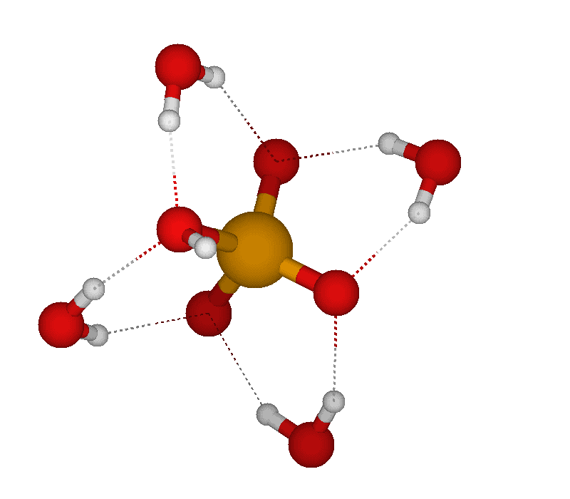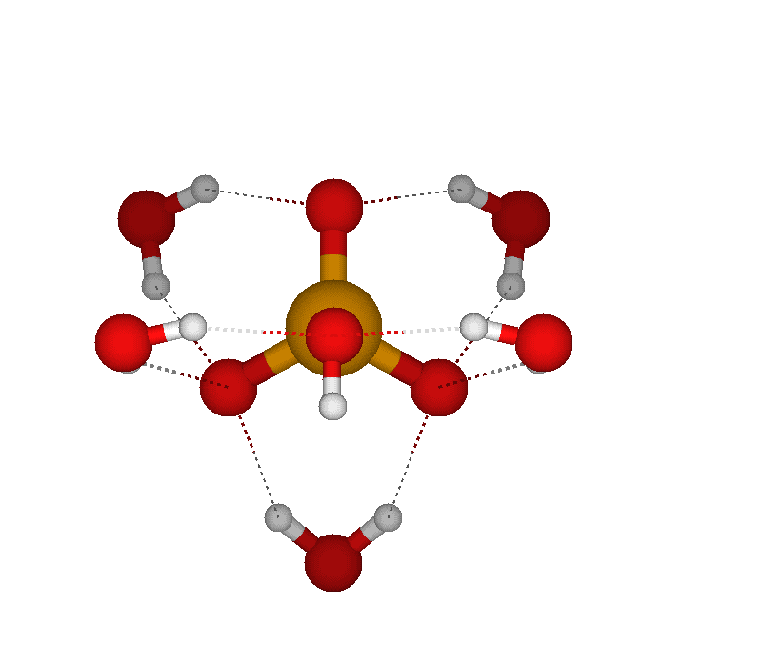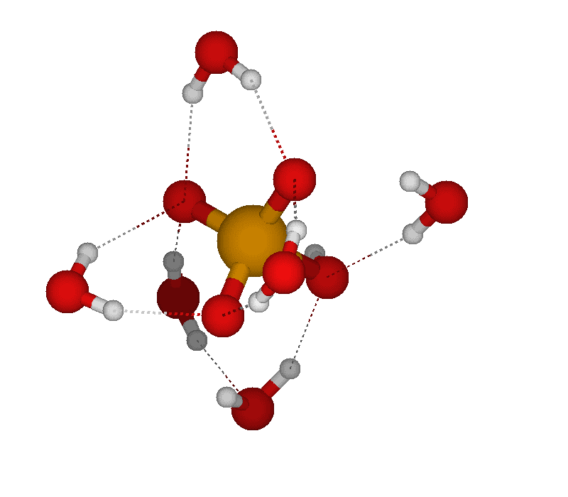
HVO₄²⁻ (H₂O)₄ HVO₄²⁻. (H₂O)₅ HVO₄²⁻. (H₂O)₆
Theoretical Study of the Deamination Reaction of Glutamine with H₂O and OH⁻

Mohammad A. Halim (GS, mahalim@mun.ca), Mansour H. Almatarneh, Raymond A. Poirier

Department of Chemistry, Memorial University, St. John's, NL, Canada A1B 3X7

Ab initio and density functional theory calculation have been carried out to investigate the possible mechanism for the deamination reaction of glutamine with H₂O and OH⁻ to produce glutamic acid and ammonia or ammonium. Interestingly, no theoretical or experimental study have been reported for this reaction which could provide us with new insight for understanding the molecular basis for the catabolic production of toxic ammonia whose excessive amount leads to hyperammonemia disease. Equilibrium geometries of reactants, transition states, intermediates and products were optimized with HF/6-31G(d), B3LYP/6-31G(d) levels and for anions at the B3LYP/6-31+G(d). Single point calculations were also performed with Gaussian n-theories such as G3B3 and G3MP2B3. Thermodynamics properties (ΔE, ΔH, ΔG), activation energies, enthalpies and free energies of activation were calculated for each reaction pathway. To confirm and characterize the transition states on the potential energy surface, intrinsic reaction coordinate (IRC) analysis was employed. Our initial finding revealed that the reaction with OH⁻ followed a two-step mechanism whereas the reaction with H₂O followed both a one-step and two-step mechanism. Moreover, the reaction mechanism for protonated glutamine with water is also favourable and proceeds through several steps.

[1] Nelson, D. L.; Cox, M. M. Lehninger Principles of Biochemistry; W. H. Freeman & Co.; 2008.
Structures of aluminum nanoparticles using an evolutionary algorithm

Carl Haugen (UG, cchaugen@sciborg.uwaterloo.ca) and Ajit J. Thakkar

Department of Chemistry, University of New Brunswick, Fredericton, NB E3B 5A3

An evolutionary algorithm is coded using a blend of ideas found in the literature; for an introduction, see Coley’s book [1]. It is tested on Lennard-Jones clusters of up to 150 atoms and found to successfully reproduce known globalminima [2, 3]. The algorithm is then applied to nanoparticles of aluminum atoms, Al_{n} (2 ≤ n ≤ 100), interacting via the NP–B potential energy function [4]. We reproduce previously reported global minima for 2 ≤ n ≤ 62 and for n = 65 [5]. We report better candidates for the n = 63 and n = 64 global minima, and the first putative global minima of aluminum clusters with 66 ≤ n ≤ 100.

[1] D. A. Coley. An Introduction to Genetic Algorithms for Scientists and Engineers. World Scientific, Singapore (2003).
[2] D. J. Wales, J. P. K. Doye. J. Phys. Chem. A 101 (1997) 5111.
[3] D. J.Wales, J. P.K.Doye,A.Dullweber,M. P.Hodges, F.Y.Naumkin, F. Calvo, J. Hernández-Rojas, T. F. Middleton. The Cambridge Cluster Database, http://www-wales.ch.cam.ac.uk/CCD.html.
[4] A. W. Jasper, N. Schultz, D. G. Truhlar. J. Phys. Chem. B 109 (2005) 3915.
[5] Z. H. Li, A. W. Jasper, D. G. Truhlar. J. Am. Chem. Soc. 129 (2007) 14899.
Structures and bonding in neutral, cationic and dicationic ozone complexes with alkaline-earth metals

Emilie Hebert (UG, x2007tpp@stfx.ca), Galina Orlova

Department of Chemistry, St. Francis Xavier University, P.O. Box 5000, Antigonish NS Canada, B2G 2W5
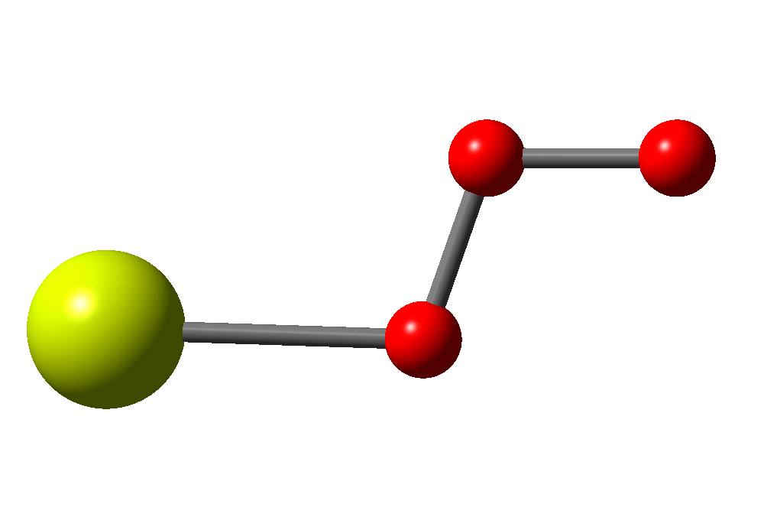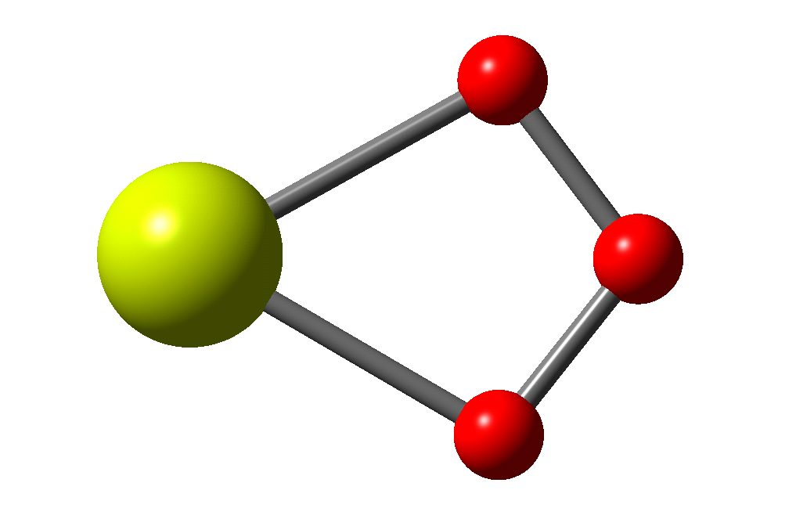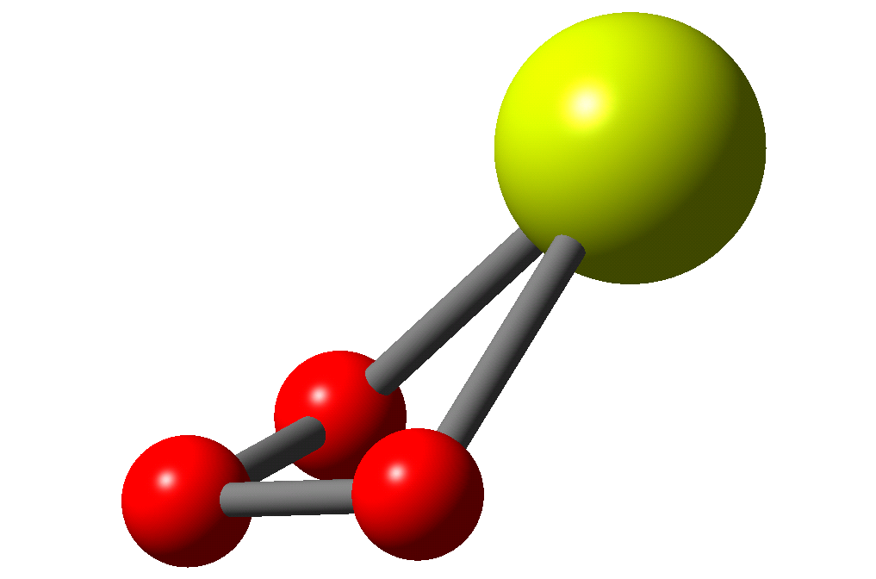
Complexes comprised of an alkali-earth metal bound to an ozone ligand are very important in atmospheric chemistry. Neutral complexes (MO₃ where M= Be, Mg, Ca, Sr, Ba), as well as cationic (MO₃^{+.}) and dicationic complexes (MO₃²⁺) were studied using B3LYP with 6-311+g(2df) and LanL2DZ. For neutral and mono-cationic complexes, ozone oxidized metal centers to produce [M²⁺O₃²⁻] and [M²⁺O₃⁻]^{+.}, respectively. Three types of geometries were found: the monodentate, C_{s}, the bidentate planar C_{2v}, as well as the bidentate puckered ring, C_{s}. The type of bonding within each category of complex depends on the charge of the ozone ligand as well as the nature of the metal center. The nature of the metal-ozone bonding was scrutinized using NBO analysis in order to determine the degree of ionic and covalent character within each M-O bond. The ozone ligand forms a covalent bond by donation to the vacant orbitals (essentially s-type) of the metal center.
Effect of monosubstitution on the antioxidant efficiency of tertiary-benzylamine selenols

Gavin S. Heverly-Coulson (GS, gavinshc@dal.ca) and Russell J. Boyd

Department of Chemistry, Dalhousie University

Organoselenium compounds which mimic the behaviour of antioxidant enzymes in the body, like glutathione peroxidase, have been proposed as a way to protect tissue from oxidative damage, which has been linked to many degenerative conditions. We have previously determined the mechanism for peroxide reduction by organoselenium compounds of the tertiary-benzylamine diselenide form using electronic structure methods (J. Phys. Chem. A, 114 (2010) 1996-2000). We showed that the zwitterionic form of the selenol is the most active for reduction of hydrogen peroxide.

In this work, the effects of introducing electron donating (NH₂, OMe, CH₃) and electron withdrawing (NO₂, CF₃, CN, F) groups to N,N-dimethylbenzylamine-2-selenol on its reduction of hydrogen peroxide are studied to determine the effect the electron density on the selenium atom has on the peroxide reduction reaction. The effects of changing both the electronic and steric environment around the selenium centre are studied using energetics, quantum theory of atoms in molecules (QTAIM), and electrostatic potential analysis.
Theoretical study of charge-shift bonding in propellanes: QTAIM and ELF approach

Dr. C. Dale Keefe and Zuzana Istvankova (UG, i_zuzana@ns.sympatico.ca)

Department of Chemistry, Cape Breton University, Sydney, Nova Scotia B1P 6L2, Canada

ABSTRACT

Alongside the classical covalent and ionic bond families, a new model of chemical bonding has been described in the literature, called the charge-shift bond. It has been suggested that the inverted CC bond in [1.1.1]propellane is a charge-shift bond, characterized by large covalent-ionic resonance interaction energy, depletion of electron density in the region between two bridgehead carbon atoms and the absence of a disynaptic Electron Localization Function basin in the middle of the bond. In the present study, the properties of the central CC bond in propellanes were investigated employing Natural Bond Orbital analysis, Quantum Theory of Atoms in Molecules and the Electron Localization Function approach. The nature of the bridging carbon-carbon bond in propellanes changes with the increasing ring size continuously from a strong charge-shift character, through a weak charge-shift and a weak covalent bond, to a strong covalent type of the bond. The substitution of the CH₂ groups at the wings of small ring size propellanes with NH, O, SiH₂, PH and S groups were also considered. The substitution of CH₂ group with a strong electron donor generally increases the strength of the central bond, while a weak electron donor, such as SiH₂ group has an opposite effect.
Nonempirical Density-Functional Theory for van der Waals Interactions

Felix O. Kannemann (GS, felix.kannemann@dal.ca), Alya A. Arabi and Axel D. Becke

Department of Chemistry, Dalhousie University

Density-functional theory (DFT) is the most widely used and successful method for electronic structure calculations in physics, chemistry, materials science and beyond. However, standard DFT fails to describe the London dispersion interaction.
Dispersion is the weakest of van der Waals (intermolecular) interactions, but ubiquitous in nature and hence fundamentally important for the stability and properties of both living and non-living matter. The significance of dispersion interactions in biological systems has only recently been realized, and they are now known to be just as important as hydrogen bonding for the structure and function of biomolecules. For instance, the dispersion interaction bewteen stacked nucleobases is responsible for the double helix structure of DNA, while hydrogen bonding between base pairs merely holds the two DNA strands together.
Becke and Johnson have developed a nonempirical dispersion model which we have combined with standard DFT to give a computational method applicable to both chemical bonding and van der Waals interactions. The method provides accurate binding energies for a test set of 65 intermolecular complexes, ranging from the helium dimer to large biomolecular complexes. We are currently working on geometry optimizations of van der Waals systems using this newly developed method.
Magic numbers for water nanodroplets

Sergey Kazachenko (GS, sergey.kazachenko@unb.ca) and Ajit J. Thakkar

Department of Chemistry, University of New Brunswick,
Fredericton, NB E3B 5A3

Improved minima hopping [1, 2] followed by an evolutionary approach to optimization of hydrogen bond topologies [3] is used to locate putative global minima of TIP4P water clusters, (H2O)n, for 36 _ n _ 50. An analysis of the energies, hydrogen bond characteristics, and various other properties of the structures is presented. Clusters of 43, 46, and 48 water molecules appear to be significantly more stable than clusters of other similar sizes. The (H2O)43 and (H2O)48 clusters have a clathrate-like structure with a coiled water heptamer in a cage.

[1] S. Kazachenko, A. J. Thakkar. AIP Conf. Proc. 1108 (2009) 90.
[2] S. Kazachenko, A. J. Thakkar. Chem. Phys. Lett. 476 (2009) 120.
[3] S. Kazachenko, A. J. Thakkar. Mol. Phys. 108 (2010) in press.

Failure of Wavefunction Theory for a C_{2h} Molecule

Mosammat Samsunnahar Khan (GS, mskhan@mun.ca ), David W. Thompson, Raymond A. Poirier

Department of Chemistry, Memorial University, St. John’s, NL, Canada A1B 3X7

Theoretical calculations of trans-oxalyl chloride using a range of basis sets unexpectedly revealed an anomalous, non-planar equilibrium structure for this molecule at MP2. Similar unusual results were also obtained for benzene and other aromatic systems using a number of popular basis sets[1]. For the planar structure, the imaginary vibrational frequency corresponds to an out-of-plane mode of C_{2h} trans-oxalyl chloride. However, computational calculations at HF and B3LYP with the same basis sets give all real frequencies for this compound. These anomalous results indicate the failure of electron correlated wavefunction theories for such C_{2h} molecules. The initial results will be presented and discussed.

[1] Moran, D; Simmonett, A. C.; Leach, F. E.; Allen, W. D.; Schleyer, P. R.; Schaefer, H. F. J. Am. Chem. Soc. 2006, 128, 9342.

The Fragmentations and Proton-Transfer Mechanisms of Cationic and Dicationic Radical Peptides: The Effects of Hydrogen Bonding

Simiao Lu (UG, x2008lrn@stfx.ca), Galina Orlova

Department of Chemistry, St Francis Xavier University, P.O. Box 5000, Antigonish NS Canada, B2G 2W5

The study of radical-cationic amino acids and oligopeptides has become an important area of mass spectrometry for structural determination of peptides. Our previous computational studies showed that the intramolecular hydrogen bonding determines structural changes upon ionization of neutral peptides: the cleavage of Cα-C bond with a spontaneous or low-energy loss of CO2 or neutral side chain in a mono-cationic radical. The radical-cationic amino acids and peptides are usually formed in a mass spectrometer upon electron-transfer dissociation of the [Cu(II)(L)(P)].2+ (L=ligand, P=amino acid or peptide) complexes. However, some radical cations, for example, Thr+., could not be formed due to their early fragmentation within the complex before the electron-transfer dissociation occurs. The mechanisms of prior fragmentations and the role of hydrogen bonding in these [Cu(II)(L)(P)].2+ complexes are not known. Three [Cu(II)(L)(P)].2+ complexes (P= Thr, GlyThr and ThrGly) are chosen in our DFT studies using B3LYP/6-31+G(d) and BHandHLYP/6-31+G(d) methods. According to our preliminary results for [Cu(II)(L)(Thr)].2+ , hydrogen bonding could not be formed in the Thr moiety, Thus, loss of the Thr side chain occurs via high reaction barrier, which is only a few kcal/mol lower than the barrier to electron-transfer dissociation.
Simple models work surprisingly well for electron correlation energies of atoms

Shane P. McCarthy (GS, shane.mccarthy@unb.ca) and Ajit J. Thakkar

Department of Chemistry, University of New Brunswick, Fredericton, NB E3B 5A3

Simple two- and three-parameter models that describe the variation of the electron correlation energy of atoms with atomic number are presented [1]. Despite their simplicity, these models have an accuracy comparable to the best available density functionals for the correlation energy [2].

[1] S. P. McCarthy, A. J. Thakkar. Chem. Phys. Lett. 494 (2010) 312.
[2] A. J. Thakkar, S. P. McCarthy. J. Chem. Phys. 131 (2009) 134109.
The Intex Distribution

Adam J. Proud (GS, aproud@upei.ca), Jason K. Pearson

University of Prince Edward Island, Charlottetown, PEI

Both the position intracule, P(u), and extracule densities, E(R), are somewhat limited in terms of the information which they provide. While the intracule density provides the probability of finding and electron pair at a separation of u, it tells us nothing about where the electrons are in space. On the other hand, the extracule density, which describes the probability of finding an electron pair whose centre of mass is at R, does provide this absolute position information but tells us nothing of the separation of the electrons in the system. Therefore, we have developed a new probability density, which we call the intex distribution, that includes both the relative (intracule) and absolute (extracule) position information. This novel probability density is highly useful in describing electron correlation effects in atomic and molecular systems, such as the recently discovered secondary Coulomb hole. The intex distribution and corresponding correlation holes were determined for the helium isoelectronic series with atomic numbers Z = 2 through 10. It was concluded that the presence of the secondary Coulomb hole is not universal at large interelectronic separation values, u, but is largely dependent on the centre of mass variable, R.

Computational Study of the Deamination Reaction of Guanine with H₂O and OH⁻

Mohammed K. Uddin(GS, mkuddin@mun.ca), Mansour H. Almatarneh, Dawn Shaw, and Raymond A. Poirier

Department of Chemistry, Memorial University, St. John’s, Newfoundland, A1B 3X7.

The mechanism for the deamination reaction of guanine to produce xanthine was investigated using ab initio calculations. Optimized geometries of reactants, intermediates, transition states, and products were determined at HF/6-31G(d), B3LYP/6-31G(d) and B3LYP/6-31+G(d) levels of theory. Single point energies were determined at Gaussian-n theories. Thermodynamic properties (ΔE, ΔH, and ΔG), activation energies, enthalpies and free energies of activation were calculated for each reaction pathway investigated. Intrinsic Reaction Coordinate (IRC) analyses were performed to characterize the transition states on the potential energy surface. Several pathways (Pathways A→E) for deamination with H₂O and OH⁻ were found. One- , two- and three-step mechanisms were found. All pathways produce an initial tetrahedral intermediate to products via a 1,3 proton shift. The results and the mechanisms for these reactions will be presented and discussed.

The Effect of Multiplicity on the Size of Iron (II) and the Structure of Iron (II) Porphyrins

Victoria Walker (GS, victoria.walker@dal.ca) and Russell Boyd

Department of Chemistry, Dalhousie University, Halifax, Nova Scotia, B3H 4J3

The functionality of the hemoglobin protein relies significantly on the unique structural characteristics of the heme group, in particular, the displacement of the iron atom from the porphyrin plane that occurs in the quintet state. Original interpretations of this effect[1], based on X-rays studies, proposed that the displacement was a result of the iron center being more spatially extended in higher spin states. The opposite has been shown to be true for free atoms.[2] In this study, density functional theory and the quantum theory of atoms in molecules (QTAIM) are used to investigate the out-of-plane displacement of iron from the porphyrin ring with respect to the spin state of iron (II). It is found that for imidazolium ligated iron (II) porphine the atomic volume of iron is smaller in the quintet state than in the triplet state. Analysis of the iron bonding environment, via the electron density (ρ) at the bond critical points (BCPs), shows that relative to the triplet state the quintet state has a stronger bonding interaction between iron and the nitrogen atoms of the porphine despite having a longer bond length. It has previously been suggested that the weakening of these bonds is the cause of the out of plane displacement of iron.[3] Since this is not the case, the magnitude of the bonding interaction between the iron atom and the axial ligand must be the significant force contributing to the domed structure of the quintet state.

[1] Hoard, J. L.; Hamor, M. J.; Hamor, T. A.; Caughey, W. S. J. Am. Chem. Soc. 1965, 87, 2312.
[2] Boyd, R. J. Nature, 1974, 250(5467), 566-7.
[3] Ugalde, J. M.; Dunietz, B.; Dreuw, A.; Head-Gordon, M.; Boyd, R. J. Phys. Chem. A. 2004, 108, 4653.

Structures of argon clusters using an evolutionary algorithm

Jordan Weagle (UG, l5zb3@unb.ca) and Ajit J. Thakkar

Department of Chemistry, University of New Brunswick, Fredericton, NB E3B 5A3

Haugen and Thakkar’s evolutionary algorithm is used to study the global minima of clusters of argon atoms using Cahill and Parsegian’s interatomic potential [1]. Preliminary results are reported and compared with previous work [2] whenever possible.

[1] K. Cahill, V. A. Parsegian. J. Chem. Phys. 121 (2004) 10839.
[2] J. M. C. Marques, F. B. Pereira, T. Leitao. J. Phys. Chem. A 112 (2008) 6079.
An Ab Initio Investigation of Co(II) Complexes with OH⁻, H₂O and Cl⁻
Daniel Whynot (GS, daniel.whynot@smu.ca ), Dr. Cory C. Pye
Department of Chemistry, Saint Mary’s University, Halifax, NS B3H 3C3

Atomic Energy of Canada Limited (AECL) is developing a Generation IV CANDU Super Critical Water Reactor (SCWR) that is expected to come online by 2025.¹ One issue with the development of the SCWR is corrosion of pipes and valves used in the water loops of the reactor. Metals such as nickel, iron, chromium and cobalt can leach into the water to form the aqua ion at low temperatures, and at high temperatures, due to the lowered dielectric constant of water, they tend to form neutral complexes with chloride and hydroxide (possibly with water and/or ammonia, added to increase pH). The complexes of interest here are [Co(OH)_{n}(H₂O)_{m}]^{2-n} and [CoCl_{n}(OH)_{m}(H₂O)_{l}]^{2-n-m}, where n+m+l≤6. Ab initio studies were performed using various basis sets at the Hartree-Fock (HF), second-order Møller-Plesset (MP2) and B3LYP levels of theory to determine molecular geometries, bond lengths and vibrational frequencies of the complexes. The results gathered from these studies will be compared, where possible, with any literature values to measure the degree of agreement. The ab initio studies will eventually be expanded to include the other metals listed and also ammonia as a possible ligand.

DFT Studies of a Polaron in 5′-(G)_{n}-3′ (n=2,3,4) DNA cations

Jian Wu (PDF), Russell J. Boyd

Department of Chemistry, Dalhousie University, Halifax, Nova Scotia, Canada B3H 4J3

Since Watson and Crick discovered the double helix structure of DNA in 1953, the topic of charge transfer (CT) in DNA has attracted experimental and theoretical interest for possible applications in molecular electronics and gene projects. The mechanism for CT in DNA has been intensively discussed theoretically. Quantum mechanical (QM) and molecular dynamical (MD) calculations have revealed that the nature of the pi-stacked conformation, counterions (such as Na⁺ and Cl⁻) and solvated water molecules affect the rate of CT. The question becomes whether these changes can enhance the CT in DNA. A recent stochastic calculation showed that the thermal fluctuations of pi-stacked conformations would blur these effects, the average structure does not significantly affect the CT process in DNA.
However, our present calculations have confirmed the existence of a polaron in DNA, and we believe this thermally stable configuration would enhance the CT in DNA. To investigate a hole polaron in B-form 5′-(G)_{n}-3′ (n=2,3,4) DNA molecules, the ONIOM(B97D/6-31(G):Amber) method is used to optimize the neutral DNA and cation DNA geometries. Here the effects of counterions and water molecules are described by the Amber/parm99bsc0 force field, and the polaron formation is discussed with respect to geometry distortion and charge distribution in pi-stacked nucleobases.

[1] Long-range Electron Transfer in DNA; Schuster, G. B., Ed.; Topics in Current Chemistry 236 and 237; Springer: Berlin, 2004.
[2] Charge Transfer in DNA; Wagenknecht, H.-A., Ed.; Wiley-VCH: Weinheim, Germany, 2005.
[3] Conwell EM, Bloch SM, McLaughlin PM, Basko DM, J. Am. Chem. Soc. 129, (2007), 9175.
[4] Alexander A. Voityuk, J. Phys. Chem. B 113, (2009), 14365.
[5] Guiqing Zhang, Peng Cui, Jian Wu, Chengbu Liu, Physica B 404, (2009), 1485.
Ab Initio Study of Vanadium (V) species at Low pH

Yaoting Zhang (GS,yaoting.zhang@smu.ca), Cory C. Pye

Department of Chemistry, Saint Mary’s University, Halifax, NS B3H 3C3

Vanadium (V) is well-known for its complex aquachemistry. Recent success of vanadium (IV) and (V) in drug industry has attracted attention to their aquachemistry[1]. VO₂⁺[H₂O]_{n,} where n=0-4, and H₃VO₄[H₂O]_{m} , where m =0-6 are predominant species of vanadium (V) at pH below 4 and exist only at low concentrations. Hydrated molecular model of these two species were computed at ab initio MP2 and B3LYP theory levels. Calculated hydrated structures were compared in terms of theory level, energies molecular geometries, bond lengths and frequencies.

[1] Thompson, K.H., Lichter, J., LeBel, C.L., Scaife, M.C, McNeill, J.H., Orvig, C. J. Inorg. Biochem. 2009, 103, 554.

